Pizza course probabilistic library
The aim of the course
The goal of this pizza course is to become familiar with the Deltares probabilistic library, which can be accessed from Python.
The library provides methods for conducting reliability analysis, system analysis, uncertainty analysis, and sensitivity analysis. It is highly validated—having been used in the assessment of primary flood defences in the Netherlands and in the Probabilistic Toolkit. The library is user-friendly and supports connecting to models provided as e.g. executables or DLLs.
Target group
Deltares colleagues who apply probabilistic concepts in their projects and/or are interested in learning more about them.
Required skills
- Basic Python skills
- Intermediate-level knowledge of probabilistic concepts such as random variables, correlations and reliability analysis.
The date and location
Date: 3th of June 2025, time: 16.00 – 20.00, location: Paviljoen.1, Deltares Delft.
Program
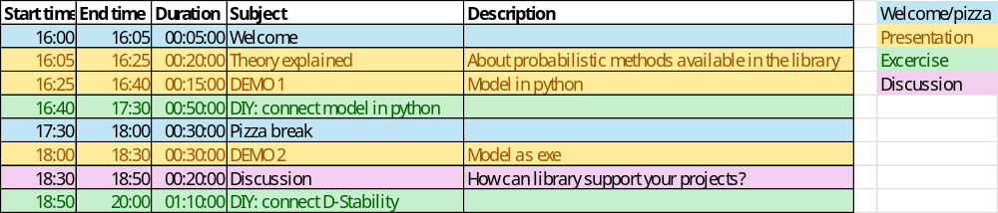
Necessary preparation
Please conduct the following steps before the pizza course. If you experience any problems, contact us before the pizza course and we will help you to solve them.
- Ensure that you have the miniforge installed (https://conda-forge.org/miniforge/).
  - Add Miniforge to PATH environment variables.
- Install Visual Studio Code (https://code.visualstudio.com/download)
  - Then install the following extensions: Python, Python Debugger, isort, Pylance, Jupyter.
- Download the pizza course folder, unzip it and place it locally.
- Open Command Prompt in the folder and:
  - Create environment: python -m venv .venv
  - Activate the environment: .venv\Scripts\activate
  - Install the wheel of the probabilistic library: pip install wheels\probabilistic_library-25.3.1-py3-none-any.whl --force-reinstall
  - Install the wheel of the Probabilistic Toolkit: pip install wheels\ptk-25.2.1-py3-none-any.whl --force-reinstall
  - Install numpy: pip install numpy
  - Install matplotlib: pip install matplotlib
- Open Visual Studio Code and navigate to the folder notebooks_course.
- Activate the .venv environment in Visual Studio Code.
- You should now be able to successfully run the following notebook from Visual Studio Code: demo_overtopping.ipynb
  - You will be asked to install ipykernel, choose 'Install'.
Operational preparation
We will have time to analyse two cases. We have prepared data for these two cases. If you want to analyse your own Python model, please bring it with you.
How to register hours?
Education from your own department (16:00 – 17:00) and own time (17:00 – 20:00).
Registration
Through Insite.
Maximum number of participants
22

